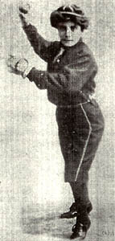

Name of Player

Position

Team

Name of player

Write 3 interesting facts

* Fact
* Fact
* Fact